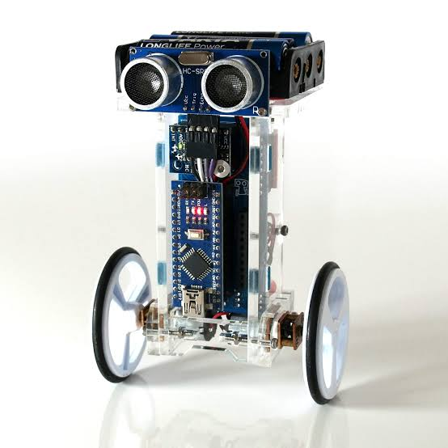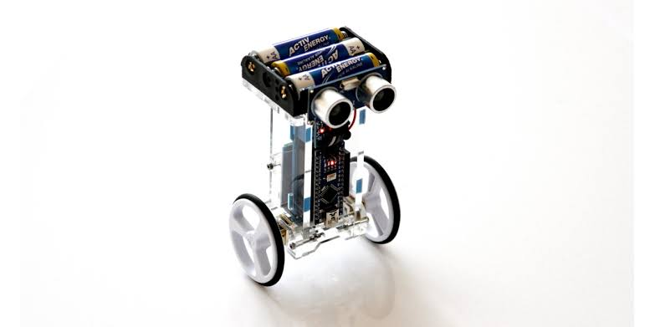SMERA- Smart Mechatronics Robot Assistant

Self-balancing robot is based on the **principle of Inverted pendulum,** which is a two wheel vehicle balances itself up in the vertical position with reference to the ground. It consist both hardware and software implementation. Mechanical model based on the state space design of the cart, pendulum system.

The language module or language faculty is a **hypothetical structure in the human brain which is thought to contain innate capacities** for language

It’s software that carries out everyday tasks via voice command. It’s brings **AI and machine learning** together to recognize our voice and do what we ask it.

About us :

Little Six Better Fix

Team Leader Name: Nishchit Y V

Branch : Btech

Stream :AI&ML

Year : II

Team Member 1 Name: Vivek kumar

Branch : Btech

Stream :AI&ML

Year : I

Team Member 2 Name: Harshavardhan G

Branch : Btech

Stream : AI&ML

Year : I

Team Member 3 Name: Gagan D N

Branch : Btech

Stream :AI&ML

Year : II

Team Member 4 Name: Raihan shariff

Branch : Btech

Stream :AI&MLM

Year : II

Team Member 5 Name: Sharon Sara

Branch : Btech

Stream :CS

Year : II

Team Mentor 1 Name: Mrs. Vindhya R

Category : Academic

Expertise : AI&ML, Data science

Domain Experience (in years): 6+

Team Mentor 2 Name: Dr. S.Vagdevi

Category : Academic

Expertise : AI&ML, Data science

Domain Experience (in years): 8+

Features :

* Interactive domain specified robo.
* Interaction in 4-5 different languages.
* Two wheeled self balancing
* Sweetest voice assistant (one of your favorite companion).
* Embedded microphone and speakers
* Multi purpose domain specifications
* Future industrial and home application

Applications :

* warehouse management.
* receptionist in various sectors
* Children funny learning toy.
* Voice-based Search .
* Answering questions about products and helping customers/clients troubleshoot issues.
* Hospitality management of clients/customers without language barrier.
* Help desk tasks in various sectors.

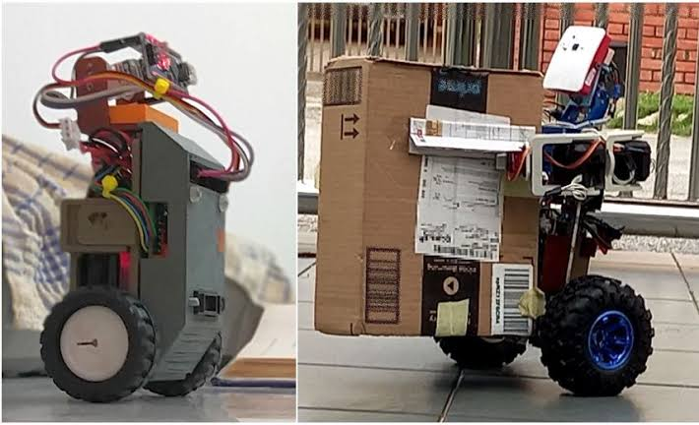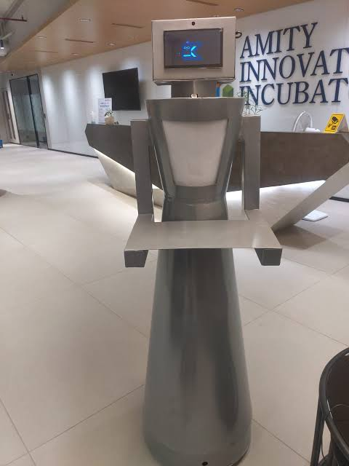

Description :

Nowadays, a human can do multiple tasks at the same time and it is because of advanced technology. Human daily work is done by machines or robots. Today, I would like to talk about a robot that I like.

They can be broadly categorized into healthcare, education, and humanoid robots based on their applications.

We do not need to type any command or press any button because it takes human voice commands. It can perform various activities like walking and interaction.

**SMERA** is one of best domain specified robot , which can be self balancing , interactive in different languages and even it can perform some simple tasks like follow humans as a pet with a highly interactive monitoring system for old people, children and even youngsters.

It as a larger scopes in larger sector as 24/7 security in charge , warehouse management , industrial help desk , patient monitoring system , service ground staff in airports and railway station with skilled communication without communication barriers.

It as been well trained with language modules . It can be used for interactive Advertiser in shopping mall and complexes. It can also look after the marketing as sales representative with its skill.

**SMERA** has just begun and would like to explore various sectors in upcoming future with more features.

Working principles and techniques :

Interaction model:

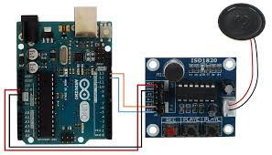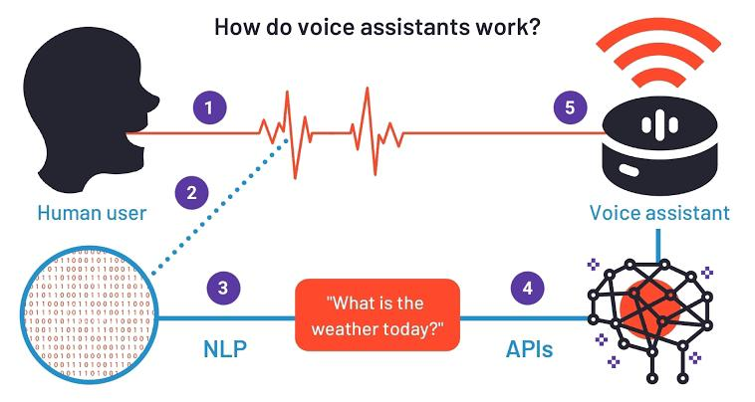

Locomotive model :

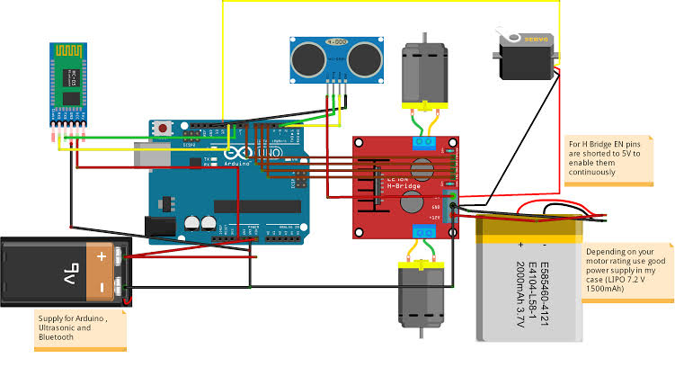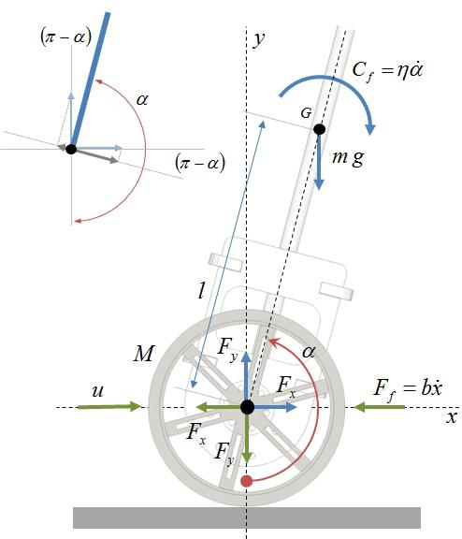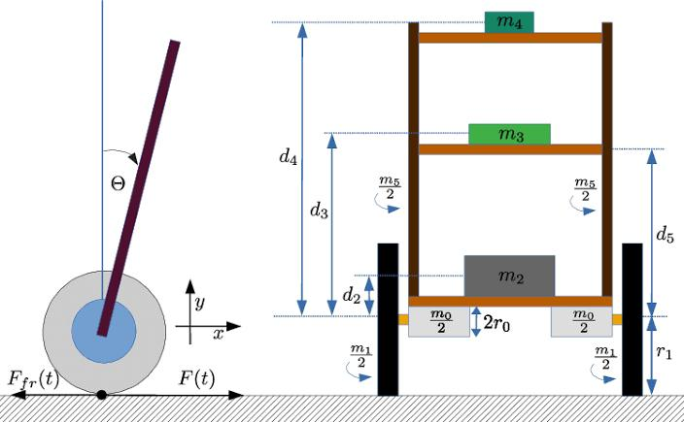

language module :

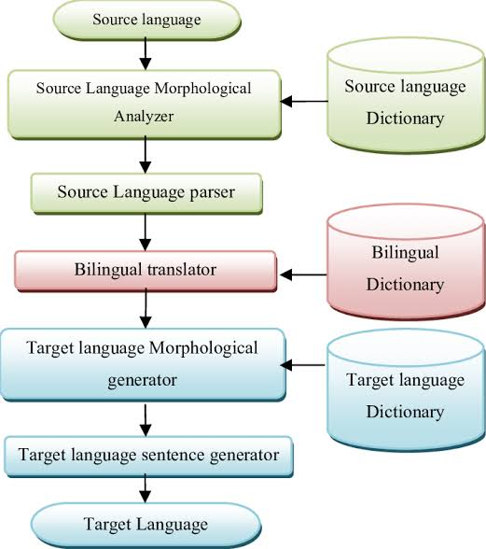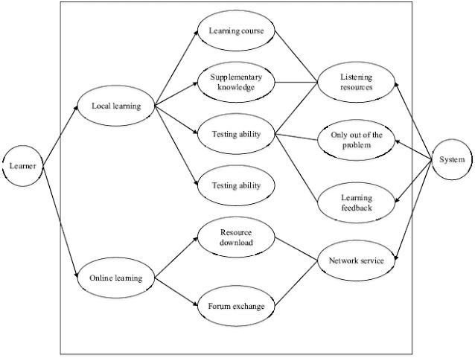

Future scope :

* Robots will increase economic growth and productivity and create new career opportunities for many people worldwide.
* Robotic technology will not only improve business efficiency and cost, but it is also an emerging industrial ecosystem that will create many new businesses, as well as drive existing companies to integrate robotic technology into their core business.
* Security in charge
* Television broadcasting
* Event management
* Help desk in larger sector
* Interactive brand Advertiser in shopping mall and complexes
* Home guardian
* Warehouse assistant
* Attractive Sales executives
* 24/7 hospital patients monitoring
* Serves ground staff in airports , Railway stations & Etc…
* Interactive survey in charge
* Etc……

Summary :

* Robots that are capable of communicating with humans through social communication modes such as speech, facial expressions and/or body language.
* Any automatically operated machine that replaces human effort, though it may not look much like a human being or function in a humanlike manner.
* More efficiency with low cost and less human efforts.
* **SMERA** is looking forward for its future growth.